|  |
| --- |
|  |



**9 November 2012** **The Weekly Bulletin of Rotary Club of Kathmandu Mid-Town** **Bc-9.11/012-13**

District : 3292 Web:www.rotarymidtown.org.np Club Id : 26776

**NOVEMBER IS THE ROTARY FOUNDATION MONTH**

The mission of The Rotary Foundation is to enable Rotarians to advance world understanding, goodwill, and peace through the improvement of health, the support of education, and the alleviation of poverty.

Friday, 2 November:

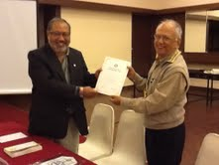

Guest Speaker, Rtn Rajesh Thapa, District Rotary

Foundation Committee Chairperson, provided a

comprehensive overview of the Rotary Foundation,

relevant updated statistics in terms of total number

and type of projects, support funds, and how Rotary

Club of Kathmandu Mid-Town shared in MG projects

and contribution to TRF fund. He also threw light on

Future Vision plan of the Foundation which is currently

being tested in pilot districts and going to be launched

in July 2013.

President Devendra handing over a certificate of appreciation to Guest Speaker Rajesh.

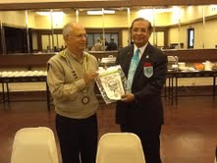

President Devendra presenting Club banner to

Visiting Rotarian Bangladesh PDG Hossain.

In exchange PDG Hossain presented a book

authored by him.

# Weekly Meetings and Programs :

|  |  |  |
| --- | --- | --- |
| Date | Program/Speaker | Program/Topics of Presentation |
| 9 Nov 2012 | HE Frank Meyke,  German Ambassador to Nepal | Professional experience as a diplomat |
| 19 Nov 2012 | Charter Night | Charter Night |

Friday, 9 November:

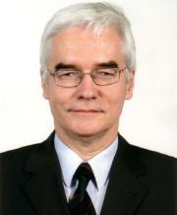

HE German Ambassador to Nepal, Frank Meyke, will be speaking, as Guest speaker, on his

professional experience as a diplomat. HE Frank joined foreign service in 1979 and started his

diplomatic career with his assignment in Nairobi in 1979. Since then he has served in many

countries in diplomatic missions. Before coming to Nepal he was German Ambassador to

Zambia (2009-12) and prior to that German Ambassador to Bangladesh (2006-09).

HE Frank will be joining Rotary Club of Kathmandu Mid-Town very soon.

**Charter Night on 19 Nov, Monday:**

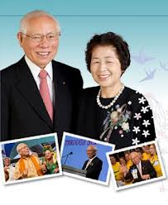

Mark your calendar: Monday 19th November !!

***RI President Sakuji Tanaka will be the Chief Guest***

***in the Club’s Charter Night celebration****.*

***RI First Lady Kyoko will be there together****.*

Also there will be induction ceremony to have inducted three new

members in the Club during the Charter Night program.

RI President Sakuji and First Lady Kyoko

**RI President Sakuji Tanaka Visiting Nepal:**  Scheduled programs -

Monday 19 November      17:00 - 18:30 hrs    Reception with Major Donors of RID3292

18:30 hrs onwards  Charter Day Dinner of RC Kathmandu MidTown

Tuesday 20 November      12:30 - 14:00 hrs    Gopal-Kamala Rajbhandari Rotary Award for Vocational Excellence

16:30 - 21:30 hrs    The Rotary Foundation Seminar

Wednesday 21 November   8:00 – 13:00 hrs     The Rotary Foundation Stewardship Seminar

**Rotary news in brief from around the globe:**

**R**otary clubs around the globe have many things in common, including a commitment to service. All year long, clubs are taking action to make a difference in their communities. Here’s a roundup of recent club activities worldwide:

**Australia**

Last year, flooding in Cambodia killed 247 people and displaced more than 200,000 families. As floodwaters receded, diseases such as cholera and dengue fever emerged. The Rotary clubs of Eltham, Australia, and Phnom Penh, Cambodia, coordinated the distribution of Aquaboxes – tanks that can purify up to 290 gallons of contaminated water – to families, medical centers, and schools.

**Canada**

Malaria, tuberculosis, HIV/AIDS, and illnesses caused by lack of sanitation have devastated many villages in South Africa. In rural Hluvukani, the nonprofit Kunavelela Community Project maintains a communal garden to help nourish residents affected by disease. Last year, the Rotary Club of Bowen Island, B.C., pledged to raise funds to purchase and install a windmill, water tanks, and a basic irrigation system to support the garden. Bowen Island club members, working with the Rotary Club of Burnaby, B.C., raised more than US$12,000, and the village now has a reliable water supply.

**England**

During an event at St George’s House, Windsor Castle, 2011-12 RI President Kalyan Banerjee spoke about the success of the fight against polio. The occasion was a charity dinner celebrating a full year without a case of the disease in India. Guests included British Home Secretary Theresa May and Ian Macfadyen, constable and governor of Windsor Castle. BBC medical correspondent Fergus Walsh, who traveled to India in February for a series on the polio eradication campaign, was the event’s keynote speaker.

**Guatemala**

Lake Izabal, at 228 square miles, is Guatemala’s largest lake and an important fishing area. Fisheries biologists are working with the Rotary Club of Guatemala de la Ermita and a Guatemala City dive shop called Pana Divers to improve underwater habitats by building artificial reefs. In 2010, they sank 62 concrete balls to protect shallow-growing sea grasses and to shelter food fish such as *Vieja maculicauda* and *Mojarra luminosa*. This June, they completed the project by sinking 161 additional balls about 130 feet from shore, which should provide local fishermen with 1,500 tons of fish annually. The club raised US$10,000 for the effort through a golf tournament and barbecue cook-off.

**India**

Indian Rotary clubs’ work to eradicate polio is highlighted in a new book by Muriel Sukumaran, a retired microbiologist and wife of Past District Governor P. Sukumaran. “I wanted everyone to know Rotary was involved in a big way,” she says. The book, titled Microbia and published in July, personifies the microbes that cause influenza, smallpox, the bubonic plague, and cholera (in addition to polio) in a narrative format to make microbiology interesting to a lay audience.

**Nigeria**

Wheels of Hope, a collaboration between Rotarians in Nigeria and Traverse City, Michigan, USA, is providing free wheelchairs to polio survivors in northern Nigeria. The hand-crank wheelchairs – built and donated by the Handicapped Advocacy and Rehabilitation Center, founded in 2007 in the city of Jos – can navigate rugged terrain and are in high demand. Rotarians in Nigeria and five U.S. districts, along with the Rotarian Action Group for Polio Survivors and Associates, raised US$120,000 – including a $63,385 Rotary Foundation Matching Grant cosponsored by the Rotary clubs of Naraguta, Nigeria, and Traverse City – that has allowed the center to build 1,000 wheelchairs for polio survivors.

**USA**

Nearly 49 million Americans don’t have enough to eat – including 79 percent of students at Greene County High School in Georgia. The Rotary Club of Greene and Putnam Counties has launched Second Harvest to help neighbors who are struggling with grocery bills. In 2008, the program began collecting food that otherwise would have been thrown away from grocery stores, restaurants, and hotels. The food is distributed through local pantries and monthly events at the high school. The Rotarians are working with Boy Scouts, the Humane Society, and Meals on Wheels, and the program has provided more than 500,000 pounds of food to families.

**U.S. Virgin Islands**

In December 2010, the Rotary Club of St. Thomas delivered 49 virtual babies to four schools as part of Baby Think It Over, a program that aims to demonstrate the pressures and responsibilities of being a parent. The club raised more than $28,000 to provide the babies, which come equipped with computer chips that record how the students care for them over several days. The effort, which the St. Thomas club has sponsored since 1996, has been credited with helping to reduce the rate of teen pregnancies in the U.S. Virgin Islands.

*Source:*Rotary International News

*Peace is not something that can only be achieved through treaties, by governments,*

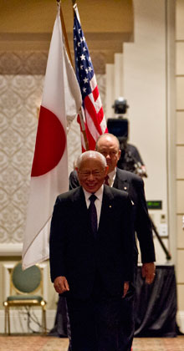

*do. or through heroic struggles. It is something that we can find and that we can*

*achieve, every day and in many simple ways*.

**RI President Sakuji Tanaka**

On Lighter Side :

Click here ⇩



**A THOUGHT FOR THE DAY:**

**We are like tenant farmers chopping down the fence around our house for fuel**

**when we should be using Nature's inexhaustible sources of energy - sun, wind and tide.**

**I'd put my money on the sun and solar energy. What a source of power!**

**I hope we don't have to wait until oil and coal run out before we tackle that.**

-Thomas Edison, inventor (1847-1931)

*courtesy:* Rtn Dr Isabella C Bassingana Khadka

**Great Quotes:**

***A hero is someone who can keep his mouth shut when he is right !***

**Wolfgang Amadeus Mozart vs. an admirer**

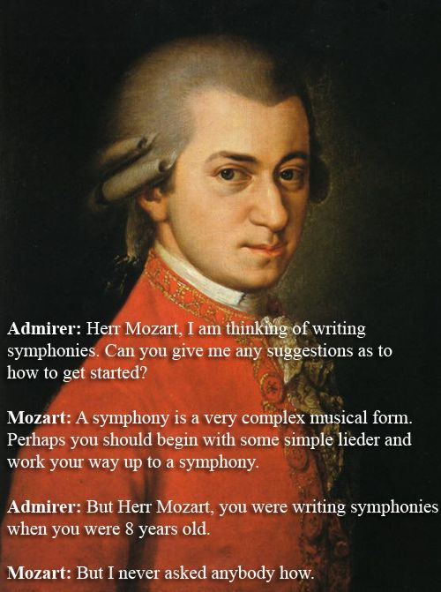

**Admirer:** *Herr Mozart, I am thinking of writing symphonies. Can you give me any*

*suggestions as to how to get started ?*

**Mozart:** A *symphony is a very complex musical form. Perhaps you should begin*

*with some simple lieder and work your way up to a symphony.*

**Admirer:** *But Herr Mozart, you were writing symphonies when you were 8 years old.*

**Mozart:** *But I never asked anybody how.*

*courtesy:* Rtn Dr Isabella C Bassingana Khadka

**A puzzle:**

*One can easily make a rectangle with four straight lines.*

*Make a rectangle with three straight lines !*

NB: If you have any information/photo that may be of interest to Rotarians send them to

BC Editor: RR Shrestha email: rryesrr@gmail.com

## 9 Nov 2012 The Weekly Bulletin of Rotary Club of Kathmandu Mid-Town bc-9.11/012-13